Student’s Name
Instructor’s Name
Course Title
Date
Chronological Timeline
Event: Creation of Adam
Date: Ca. 4004 BC
Description: Adam is created by God from the soil of the earth and breath of life put into his nostrils (Camping 18).
Birth of Seth
Ca. 3874 BC
Seth is born when Adam is 130 (Camping 21).
Birth of Enos
Ca. 3769 BC
Enos born when Seth was 105 (Camping 25).
Egyptian hieroglyphic script
Ca. 3100 BC
The Egyptian hieroglyphic script is developed at the same time as the Sumerian Cuneiform (Historyworld.net, 2020)
Wheels in carts
Ca. 3000 BC
Wheels are in use in carts, mostly where wood is readily available (Rudwick 54).
Slavery starts
Ca. 3000 BC
Slavery arrives as an integral part of civilization (Historyworld.net, 2020).
Birth of Noah
Ca. 2948 BC
Noah born when Methuselah was 187 (Camping 32).
The flood
Ca 2348 BC
The flood happen when Noah is 600 (Camping 36).
Birth of Abraham
1996 BC
Abraham is born when Terah is 130 (Camping 42).
Abraham in Canaan
Ca. 1921 BC
At the age of 75 Abraham enters Canaan (Camping 23).
Hammurabi inherits Babylon
Ca. 1728 BC
Hammurabi inherits the relatively minor kingdom of Babylon, begins a programme of conquest and coalition which vastly extends the Babylonian empire (Van de Mieroop 12).
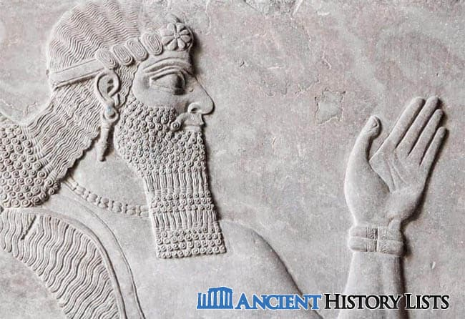
Exodus
1491 BC
Jews Exodus from Egypt (Edgerton 153).
Jews at Sinai
1250 BC
Moses with the Hebrew tribes in Sinai after getting out of Egypt (Edgerton 153).
Saul anointed King
Ca. 1020 BC
Saul is anointed by Prophet Samuel and establishes himself at Gibeah north of Jerusalem (Kelle 177).
David anointed king of Israel and Judah
Ca. 990 BC
David who is king of Judah gets anointment to be King of Israel bringing the twelve tribes of Israel into one realm (Kelle 177).
Solomon becomes King
Ca. 965 BC
Solomon becomes king of Israel presiding over an age of peace and prosperity. Five years later he builds the first Temple in Jerusalem (Kelle 177).
First Olympics
Ca. 776 BC
The first athletics contest is held at Olympia (Historyworld.net, 2020).
Egyptians develop abbreviated hieroglyphics
Ca. 700 BC
Egyptian scribes develop the abbreviated version of hieroglyphs for daily use and the script is referred to as demotic meaning for the people (Edgerton 158).
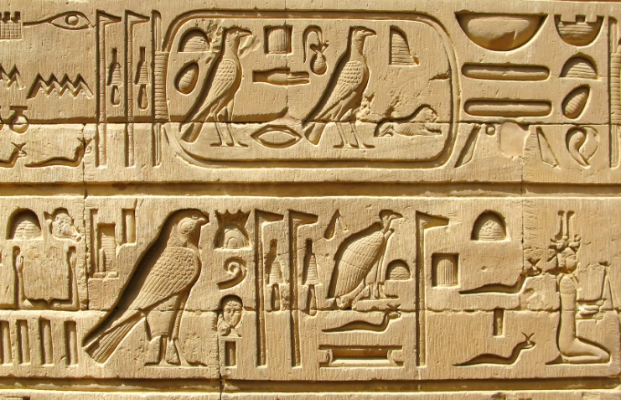
Nebuchadnezzar becomes King of Babylon
Ca. 605 bc
Nebuchadnezzar ascends to the Babylonia throne reigning prosperously for more than 40 years (Beaulieu 510).
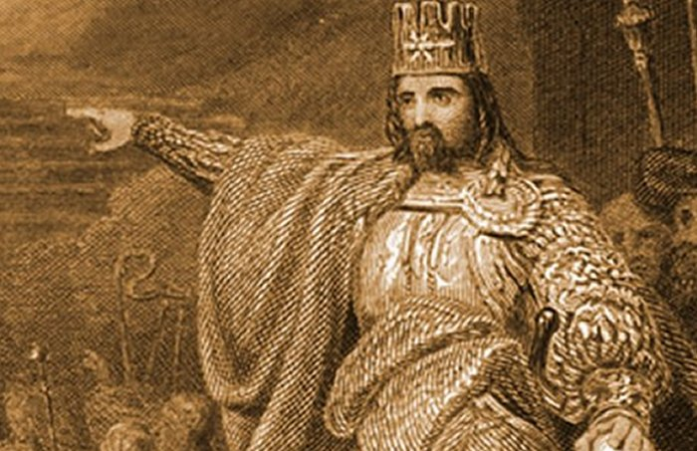
Temple at Jerusalem destroyed
Ca. 586 BC
A long siege of Jerusalem is culminated by the takeover of the city by Nebuchadnezzar who destroys Solomon’s Temple. Jews are then taken into captivity in Babylon among them Daniel, Shadrack, Meshack and Abed-Nego (Beaulieu 510).
Babylon falls to Persia
Ca. 539 BC
Persian army captures Babylon bringing into an end the great Babylonian empire. Cyrus the Great rules the Persian Empire (Historyworld.net, 2020)
Persia falls to Greece
Ca. 331 BC
Alexander of Greece defeats Darius III at the battle of Gaugamela later conquering the Persian Empire for under his rule. He dies roughly 8 years later (Historyworld.net, 2020).
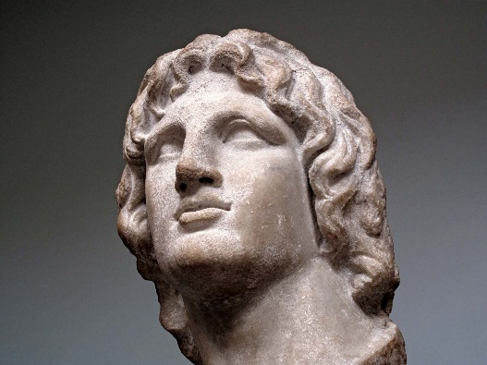
Greece falls to the Romans
Ca. 196 BC
The Romans defeat Macedon and announces that all Greeks are free under their protection. The Roman Empire flourishes for Centuries later (Historyworld.net, 2020).
Julius Caesar new calendar
Ca. 45 BC
Julius Caesar introduces his new calendar at a duration when the person he preceded had became out of step with the seasons by three months (Historyworld.net, 2020)
Annexation of Egypt by the Romans
Ca. 30 BC
The annexation of Egypt means the entire Mediterranean is subdued by the Roman Empire (Edgerton 23).
The birth of Jesus Christ
Ca. 4 BC
According to the Gospel account, Jesus Christ is born in Bethlehem (Willmington 21).
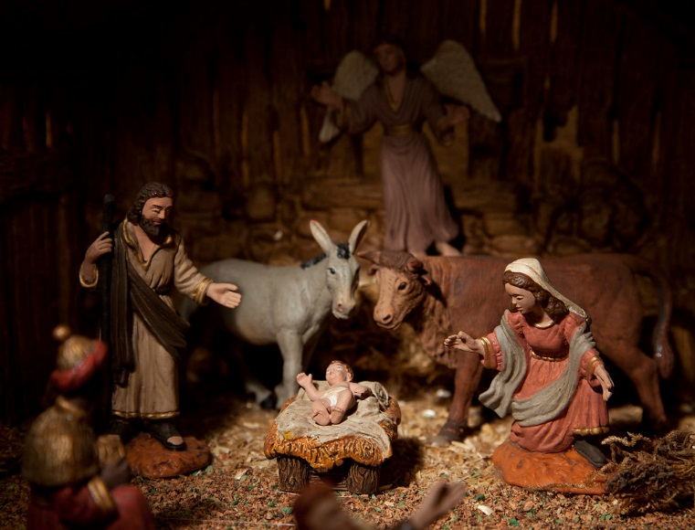

Works Cited
Historyworld.net. (2020). HistoryWorld - World History Timeline. [online] Available at: http://www.historyworld.net/timesearch/default.asp?conid=static_timeline&timelineid=5 37&page=3&keywords=World%20History%20timeline [Accessed 6 Feb. 2020].
Rosenberg, Daniel, and Anthony Grafton. Cartographies of time: A history of the timeline. Princeton Architectural Press, 2013.
Rudwick, Martin JS. "Jean-André de Luc and nature’s chronology." Geological Society, London, Special Publications 190.1 (2001): 51-60.
Van de Mieroop, Marc. King Hammurabi of Babylon: a biography. Vol. 19. John Wiley & Sons, 2008.
Willmington, Harold. "A Time Line Countdown Leading Up to Jesus' Birth-Part A." (2018).
Edgerton, William F. "The government and the governed in the Egyptian empire." Journal of Near Eastern Studies 6.3 (1947): 152-160.
Camping, Harold. "The Biblical Calendar of History." Journal of the American Scientific Affiliation 22 (1970).
Beaulieu, Paul-Alain. "Nebuchadnezzar’s Babylon as World Capital." Canadian Society for Mesopotamian Studies Journal 3 (2008): 510.
Kelle, Brad E. "The Early Monarchy and the Stories of Saul, David, and Solomon." The Wiley Blackwell Companion to Ancient Israel (2015): 177.

